Sindiswa Jachin Shongwe
Practical 2: BrightLight Data Analytics Coding Practical JOINS
----------------------------------------------------------------------------------
-- Q1 INNER JOIN: Orders with Customer and Product Names Question:
--List all orders along with the customer name and product name.
-- Expected Output Columns:
-- • OrderID, OrderDate, CustomerName, ProductName, Quantity.

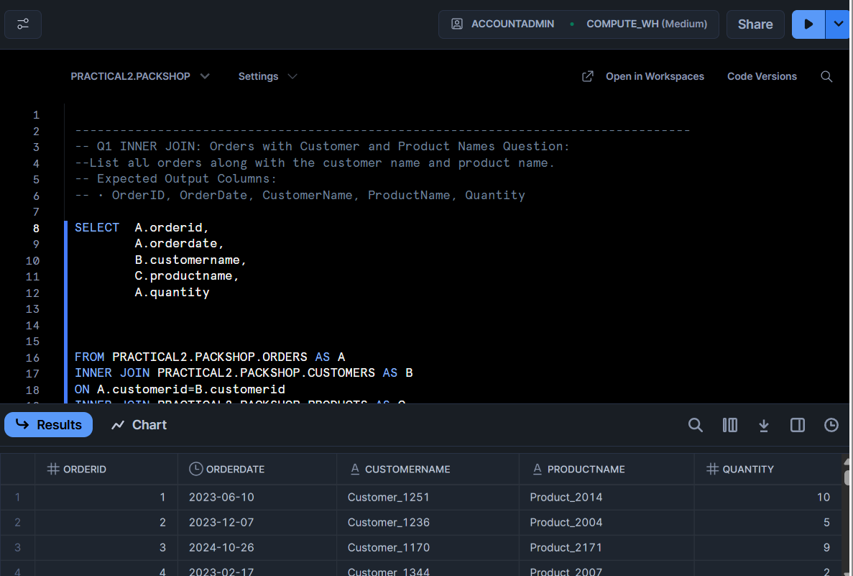

---------------------------------------------------------------------------------------------------------------------------------
-- Q2 Which customers have placed at least one order?
-- Expected Output Columns:
-- • CustomerID, CustomerName, Country, OrderID, OrderDate.

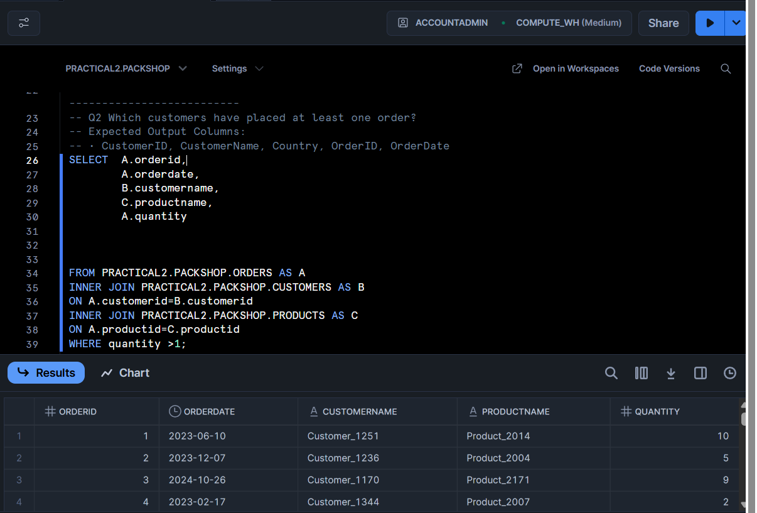

-------------------------------------------------------------------------------------------------------
--Q3. LEFT JOIN: All Customers and Their Orders
-- Question: List all customers and any orders they might have placed. Include customers who have not placed any orders.
-- Expected Output Columns:
-- • CustomerID, CustomerName, Country, OrderID, OrderDate, ProductID, Quantity.

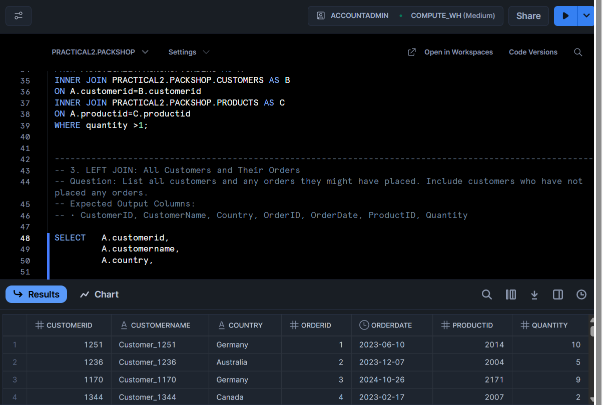

------------------------------------------------------------------------------------------------------

-- Q4. LEFT JOIN: Product Order Count
-- Question: List all products and how many times each was ordered (if any).

-- Expected Output Columns:
-- • ProductID, ProductName, TotalOrders
-- (TotalOrders is the count of how many times the product appears in orders).

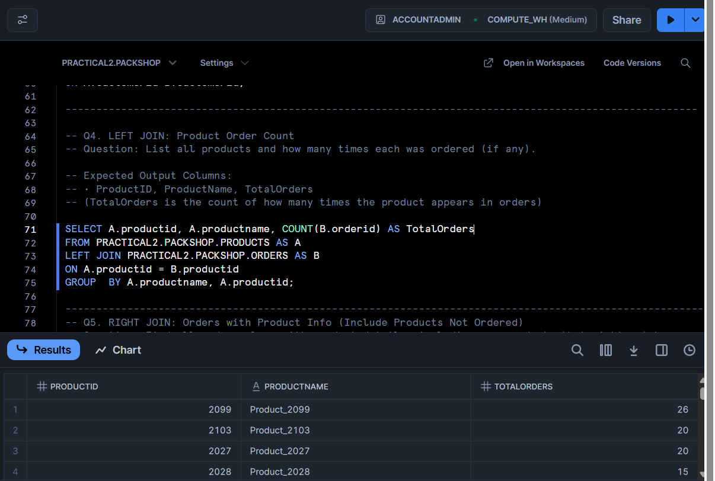

-------------------------------------------------------------------------------------------------------
-- Q5. RIGHT JOIN: Orders with Product Info (Include Products Not Ordered)
-- Question: Find all orders along with product details, including any products that might not have been ordered.
-- Expected Output Columns:• OrderID, OrderDate, ProductID, ProductName, Price, Quantity.

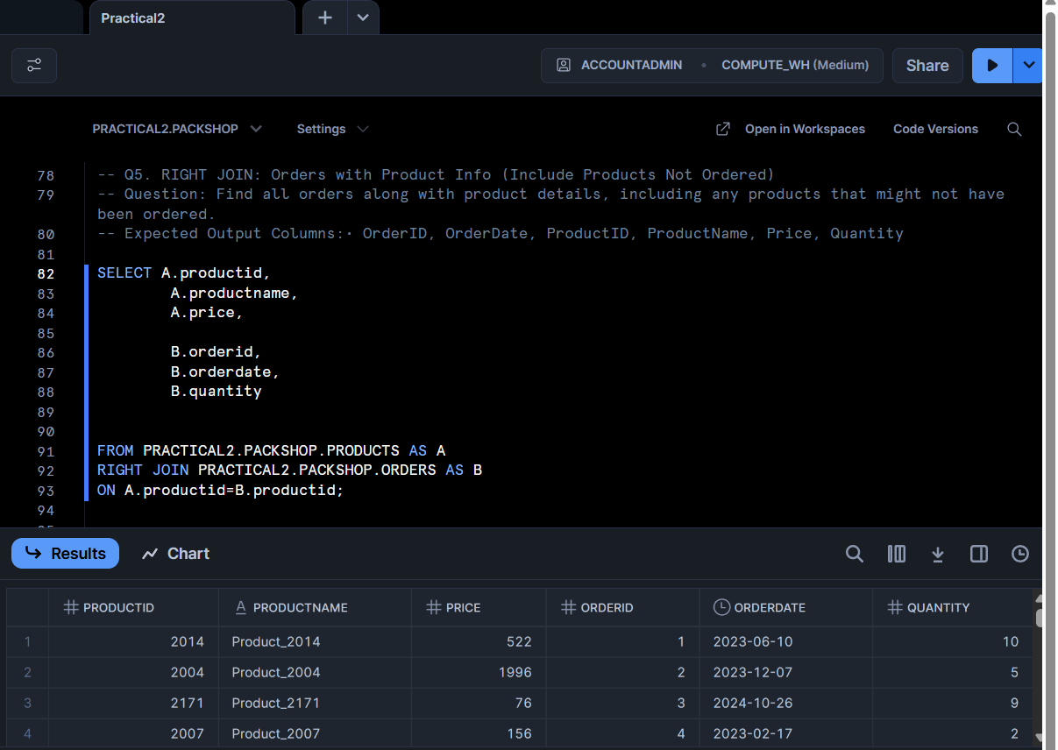

---------------------------------------------------------------------------------------------------------
Q6. RIGHT JOIN: Customer Info with Orders (Include All Customers)
-- Question: Which customers have made orders, and include customers even if they have never placed an order.
-- Expected Output Columns:
-- • CustomerID, CustomerName, Country, OrderID, OrderDate, ProductID, Quantity

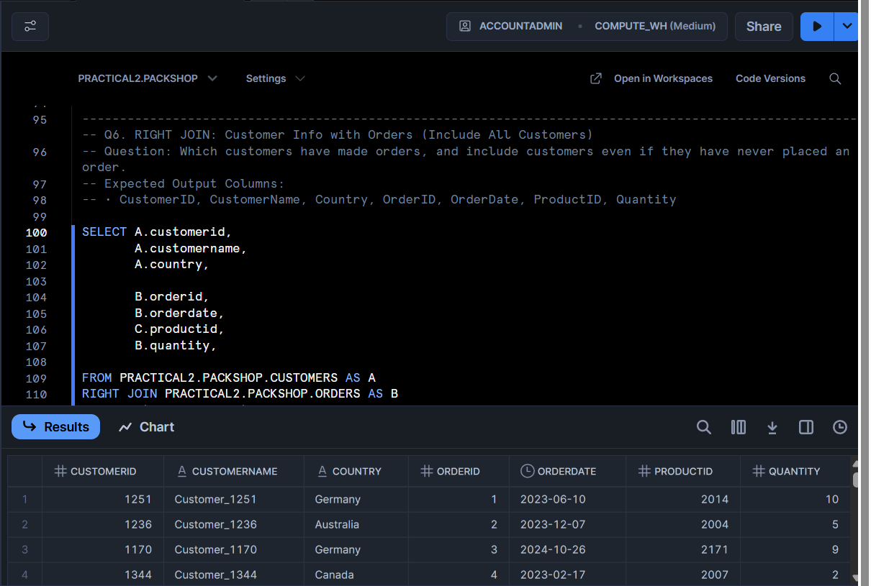

-------------------------------------------------------------------------------------------------------
-- 7. FULL OUTER JOIN: All Customers and All Orders
-- Question:List all customers and orders, showing NULLs where customers have not ordered or where orders have no customer info.
-- Expected Output Columns: • CustomerID, CustomerName, Country, OrderID, OrderDate, ProductID, Quantity.

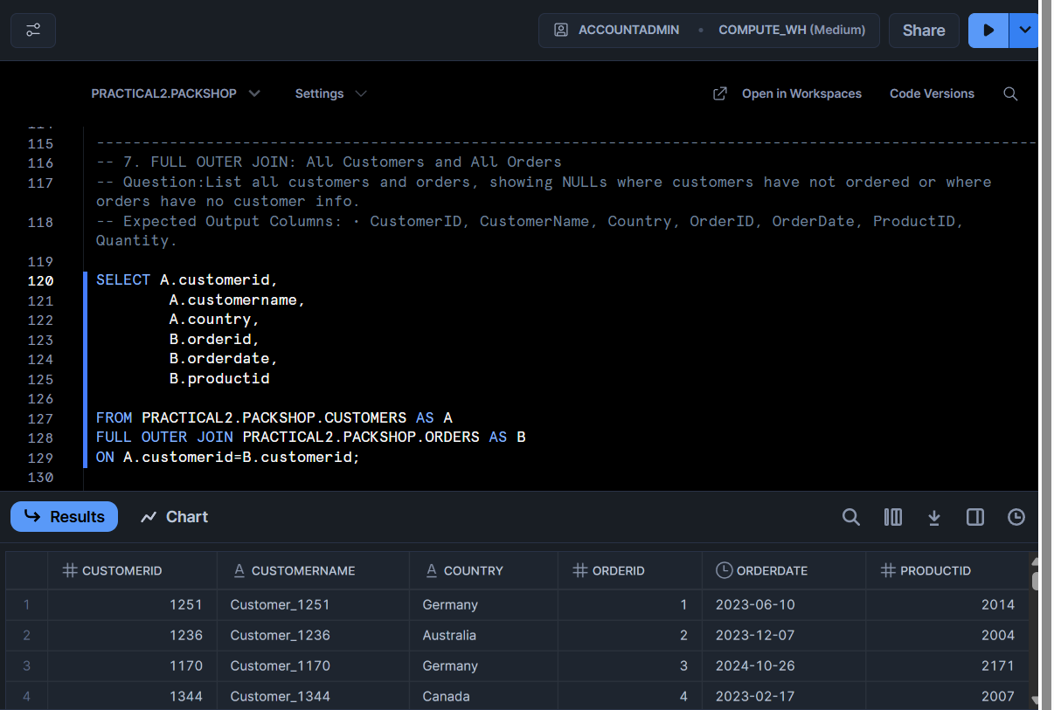

-------------------------------------------------------------------------------------------------------
-- Q8. FULL OUTER JOIN: All Products and Orders
-- Question:List all products and orders, showing NULLs where products were never ordered or orders are missing product info.
-- Expected Output Columns:
-- • ProductID, ProductName, Price, OrderID, OrderDate, CustomerID, Quantity
